**Fuel Sales SQL QUERIES**

**A. KPI’s**

1.Total Revenue:

SELECT sum(total_price) as 'Total Revenue'

from [gas_sales_excel_file(Random Data)]

2.Total Quantity:

SELECT sum(quantity) as 'Total Quantity'

from [gas_sales_excel_file(Random Data)]

3.Average Total Price

SELECT AVG(total_price) as 'AVG Total Price'

from [gas_sales_excel_file(Random Data)]

4.Average Total Quantity

SELECT AVG(quantity) as 'AVG Total Quantity'

from [gas_sales_excel_file(Random Data)]

**B. Daily Trend for Total Sales**

select DATENAME(DW,order_date) as 'Day',SUM(total_price) as 'Total Price'

from [gas_sales_excel_file(Random Data)]

group by DATENAME(DW,order_date)

**C. Monthly Trend for Total Sales**

select DATENAME(MONTH,order_date) as 'Month',SUM(total_price) as 'Total Price'

from [gas_sales_excel_file(Random Data)]

group by DATENAME(MONTH,order_date)

**D. Percentage of Sales by Fuel Type**

SELECT

fuel_type,

SUM(total_price) AS 'Total Revenue',

CONCAT(

CAST(SUM(total_price) * 100.0 / (SELECT SUM(total_price) FROM [gas_sales_excel_file(Random Data)]) AS DECIMAL(10, 2)),

'%') AS PCT

FROM [gas_sales_excel_file(Random Data)]

GROUP BY fuel_type;

**D. Percentage of Sales by Payment Method**

SELECT

payment_method,

SUM(total_price) AS 'Total Revenue',

CONCAT(

CAST(SUM(total_price) * 100.0 / (SELECT SUM(total_price) FROM [gas_sales_excel_file(Random Data)]) AS DECIMAL(10, 2)),

'%') AS PCT

FROM [gas_sales_excel_file(Random Data)]

GROUP BY payment_method;

**E. Top 3 Fuel by Revenue**

select top 3 fuel_type, sum(total_price) as Total_Revenue

from [gas_sales_excel_file(Random Data)]

group by fuel_type

order by Total_Revenue desc

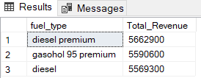

**F. Bottom 3 Fuel by Revenue**

select top 3 fuel_type, sum(total_price) as Total_Revenue

from [gas_sales_excel_file(Random Data)]

group by fuel_type

order by Total_Revenue

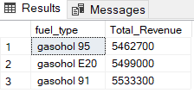

**G. Top 3 Fuel by Quantity**

select top 3 fuel_type, sum(quantity) as Total_Quantity

from [gas_sales_excel_file(Random Data)]

group by fuel_type

order by Total_Quantity desc

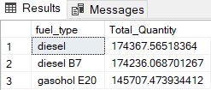

**H. Bottom 3 Fuel by Quantity**

select top 3 fuel_type, sum(quantity) as Total_Quantity

from [gas_sales_excel_file(Random Data)]

group by fuel_type

order by Total_Quantity

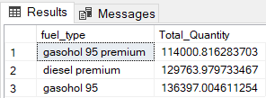

**I.Total Sales by Fuel Type**

select fuel_type, sum(total_price) as Total_Price

from [gas_sales_excel_file(Random Data)]

group by fuel_type

order by Total_Price desc

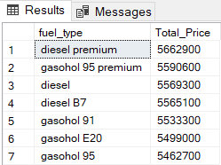

**J. Total Quantity by Fuel Type**

select fuel_type, sum(quantity) as Total_Quantity

from [gas_sales_excel_file(Random Data)]

group by fuel_type

order by Total_Quantity desc

